Links db

# Data dictionary

## type_tab*

|  |  |  |
| --- | --- | --- |
| Colum name | Type | Comments |
| Type_id | Int(11) | PK |
| Typename | Mediumtext |  |

### siteInfo*

|  |  |  |
| --- | --- | --- |
| Colum name | Type | Comments |
| Ref | Int(11) | PK |
| Disc | Mediumtext |  |
| Link | Mediumtext |  |
| sitename | Mediumtext |  |
| Typeinfo | Int(11) | Fk to type_tab |
| Location | Int(11) | Fk to location |

### location*

|  |  |  |
| --- | --- | --- |
| Colum name | Type | Comments |
| Type_id | Int(11) | PK |
| Typename | Varchar(1000) |  |

* All columns not null

## Users

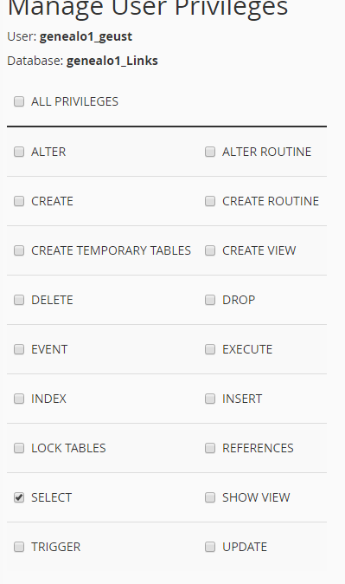

Password is Gra123!!, used in public_html/usefulLinks/ database_conn.php

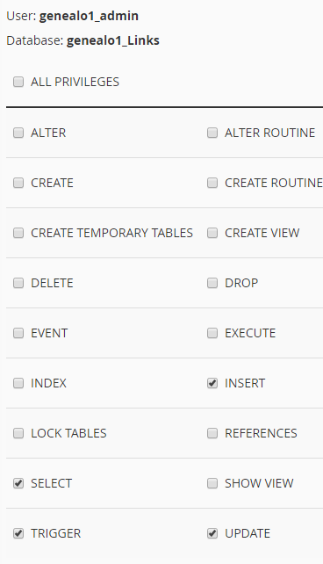

Password is Gra123!!, used in admin-stuff/links/database_conn.php

Admin use forms to add data.